Andrea T, Ulises M, Jaime M, Porfirio G, Chase B, Eduardo F

B2

**Bridge Project**

**2/27/18:**

On the first day of our project we got a well amount of work done. We decided to not assign specific parts to one another. We agreed on everyone pitching in instead as we go along. Next time we are hoping to draw the blueprints and start building.

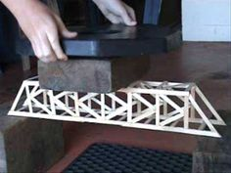

We decided on this design Chase found online.

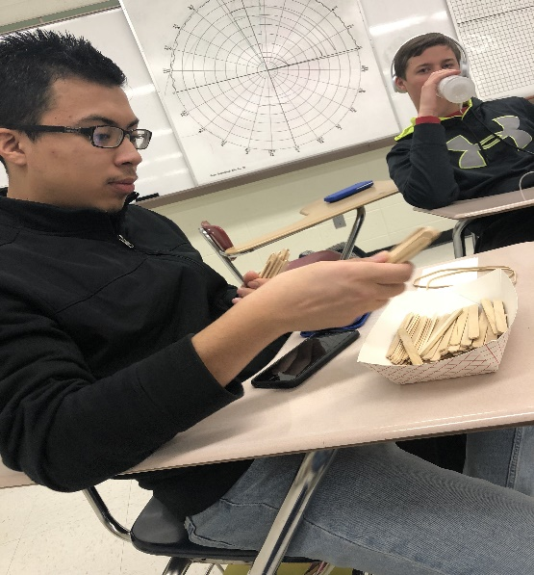

Here Ulises is counting the popsicle sticks Jaime brought over. He got 118 sticks, but Andrea made him count again. He did.

**3/1/18:**

We have decided to change our design since the one we found online used longer sticks at the ends. We started free styling and arranging the popsicle sticks in different ways. We came up with a new design.

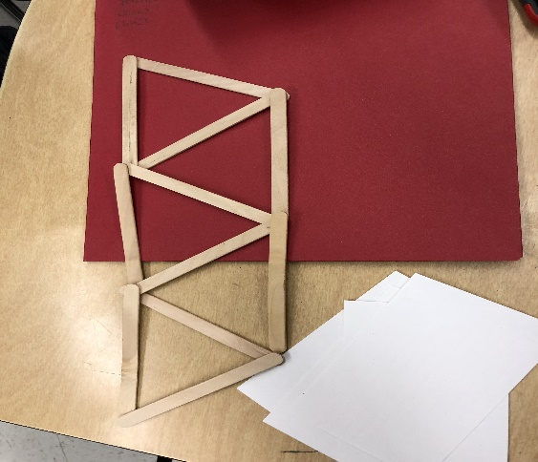

Porfirio put this idea on the table and we all agreed.

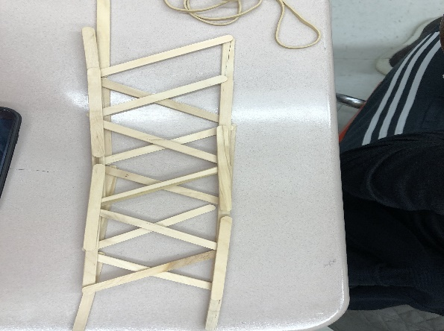

Eduardo came up with this design. It was a glow up from Porfirio’s design. Porfirio accidently moved it, so Eduardo had to redo it like 3 times.

Eduardo’s design looked like it was more pressure resistant and honestly, much cooler so we went with his design for our bridge.

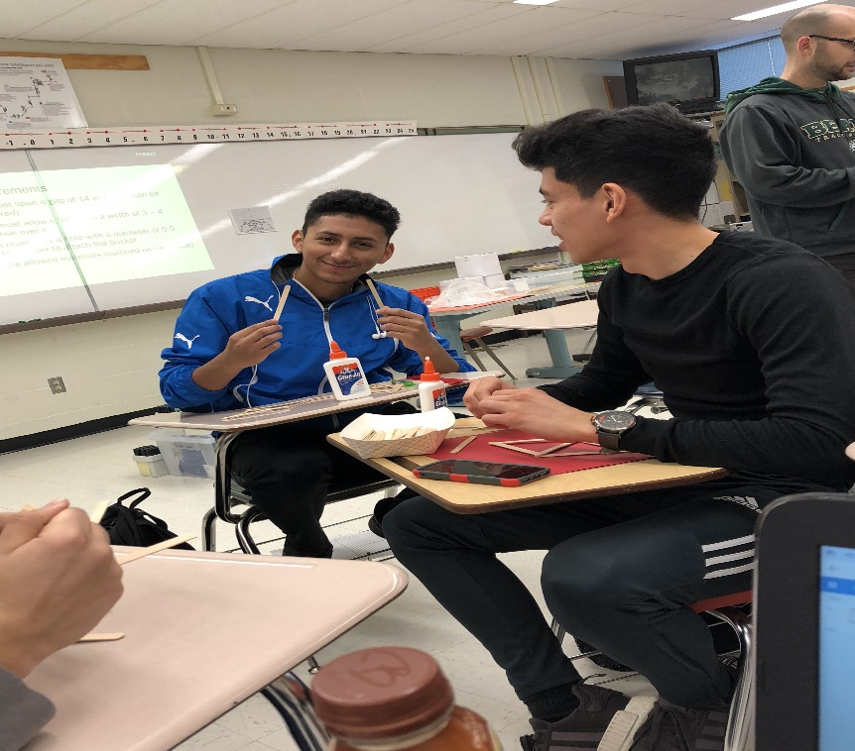

Jaime and Porfirio are gluing together the design from the layout above.

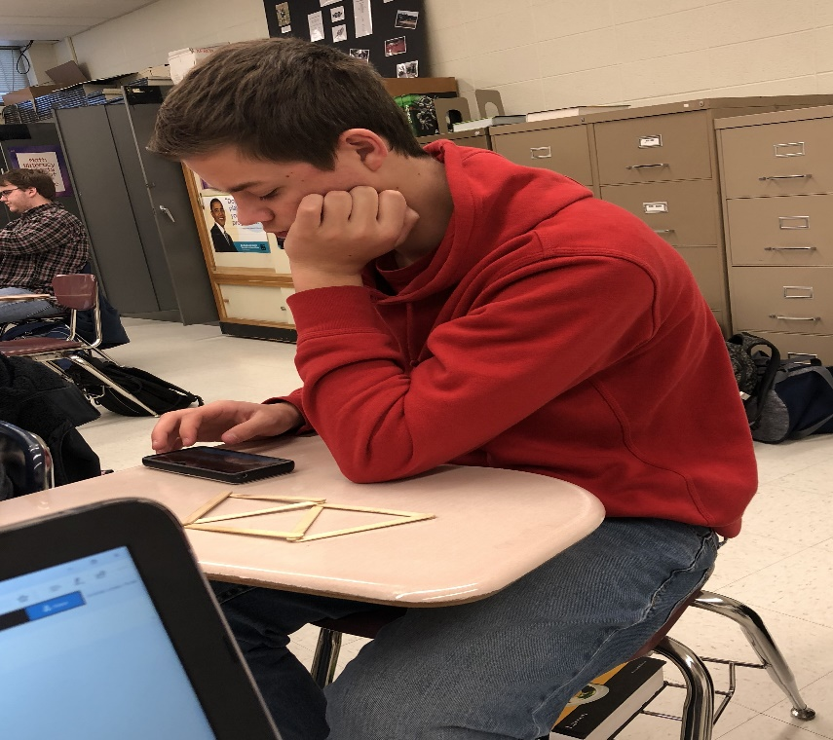

After a hard day's work, we like to take a breather.

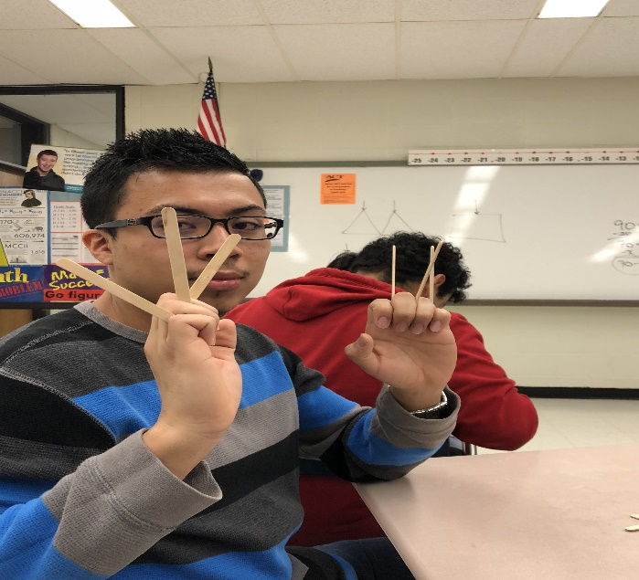

Ulises is Wolverine.

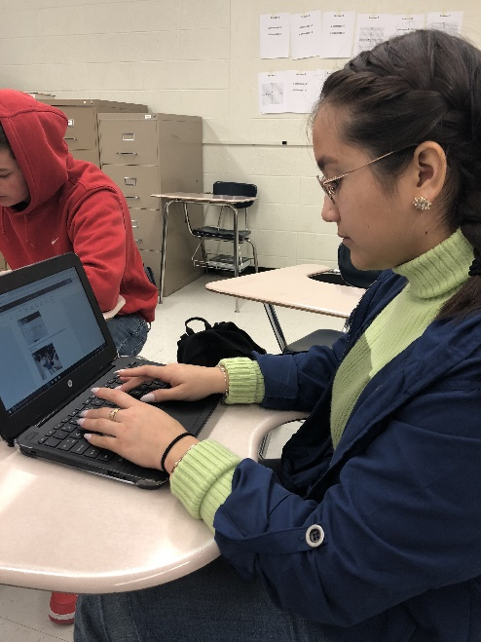

Here is Andrea getting some work done. Chase and Ulises were trying to get on me for exposing their productivity on the write up. They brought up a valid point saying there was no picture of me, so I made Ulises take one.

At the end of the class Jaime and Porfirio glued together the start of our design. Andrea was assigned to take the project home and work on it because we wanted to get a good, solid start for next time.

Ulises oversees the blue print layout, Chase is doing the base of the bridge, and we haven't decided on who's doing the math portion yet. Probably Eduardo, Jaime, and Porfirio.

**3/5/18:**

We ended up using Eduardo's design. Andrea used the 2 designs done in class and glued them together. One upside down and the other one right side up to make the "X" design we have. Andrea decided to layer it once more by 3. She made the remaining 4 layouts to complete the 2 sides for the bridge.

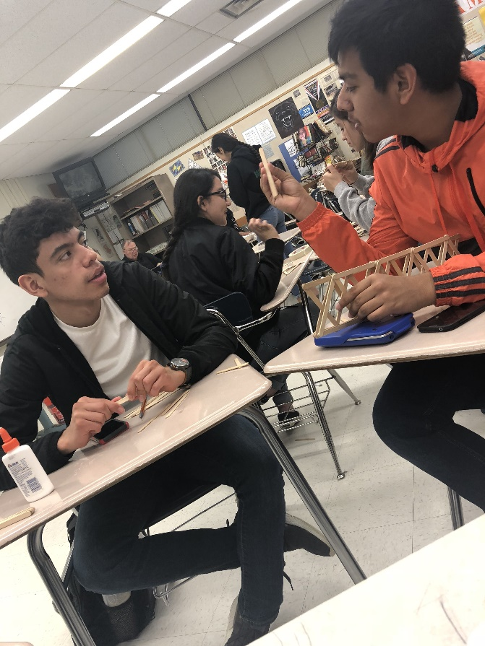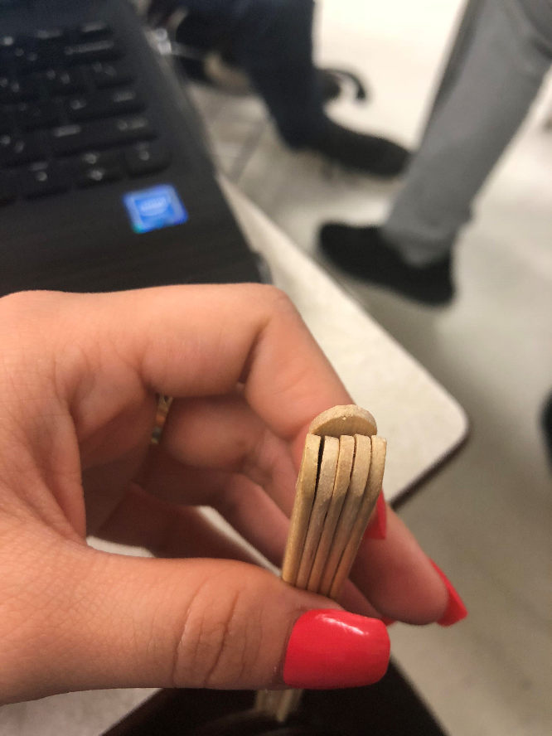

Porfirio and Eduardo are coming up with different ideas for the base. We came up with adding 5 sticks together and one stick at the bottom to make a box like design.

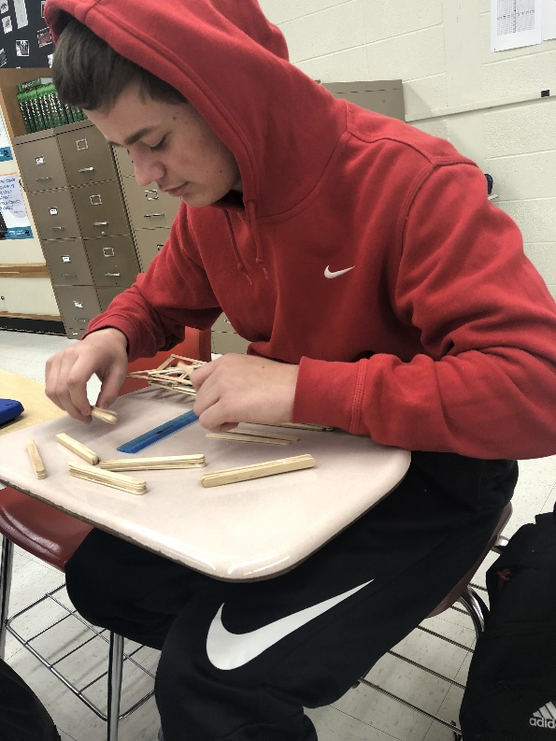

Chase is working on making the base parts. He glued the sticks together. Andrea, Porfirio, and Eduardo helped.

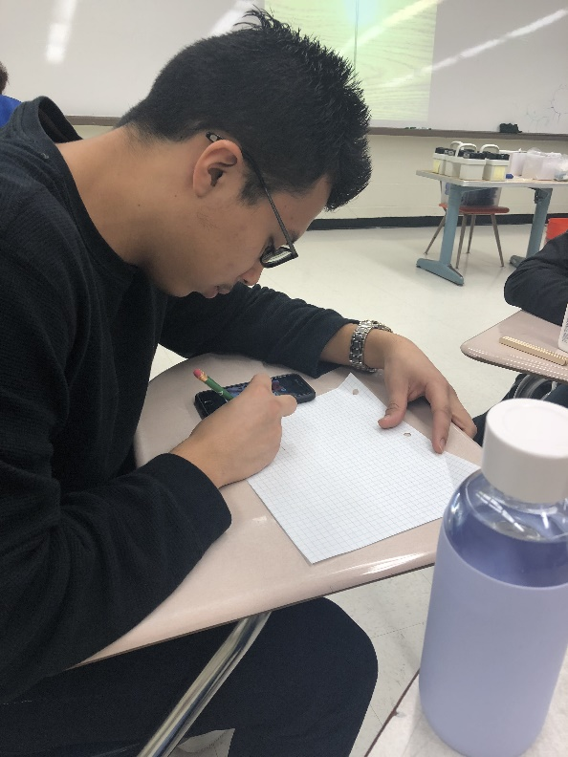

Ulises finally began on working on the blueprint. He had to first look up what blueprints were

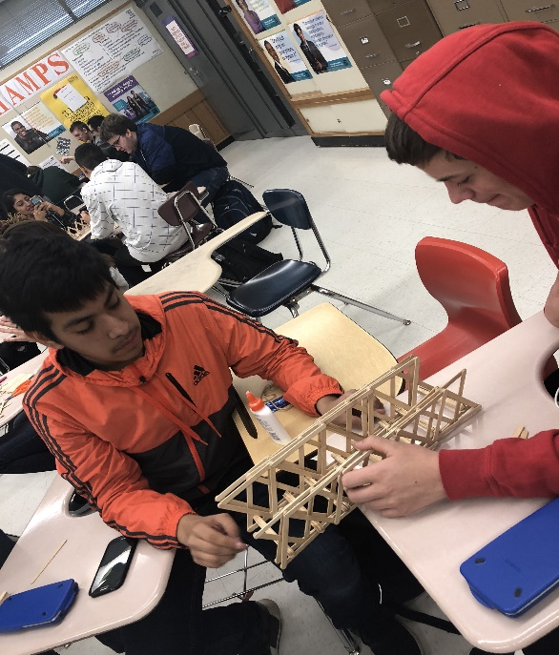

Chase and Eduardo are working together to check if our base idea will work and if it meets the requirements. We believe that by using the small block for the bucket, it will fit just right.

Jaime had to attend a TDL meeting and wasn’t present for the day.

All the base pieces were completed during class, in total there were 6 "blocks".

Andrea took the project home once again to glue the base pieces together with the sides. She ran into some trouble trying to glue the other side to the blocks because the two weren’t perfectly straight. She got one side done but the other one wasn't cooperating. For extra support she added 12 sticks on top of the base.

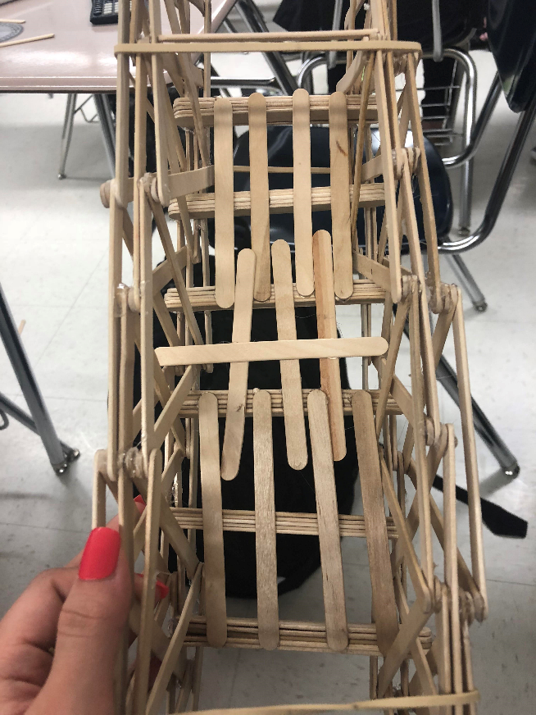

**3/7/18:**

To solve my dilemma at home we decided to use the 2 rubber bands as a method to attach the unglued side to the base part. After putting the rubber bands on, the unglued side fit into place better and was easier to glue to the base. The rubber bands overall made the bridge sturdier. We decided to not come up with a design for the top part and left the bridge open at the top.

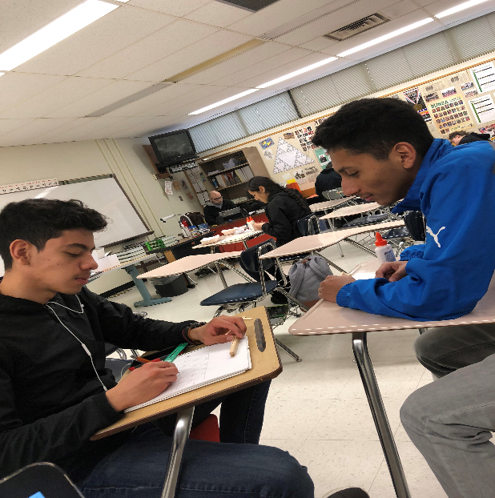

Porfirio ended up taking over the blueprint. Jaime and Porfirio worked on last minute math calculations.

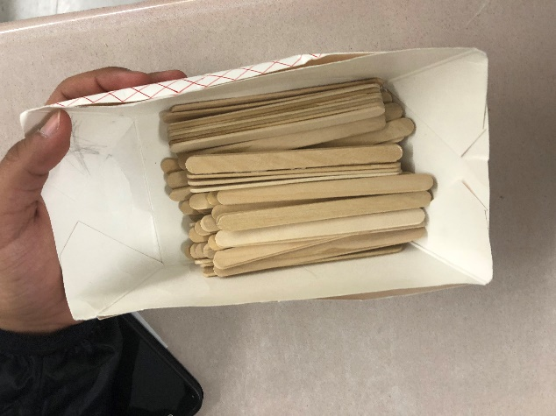

This was what was leftover after the 219 sticks we previously intended to use.

**Finished Product:**

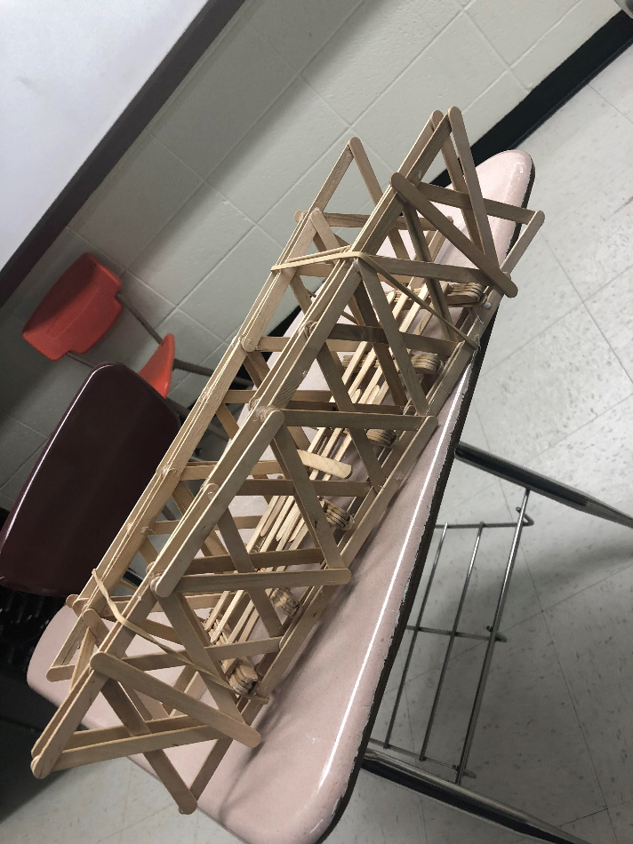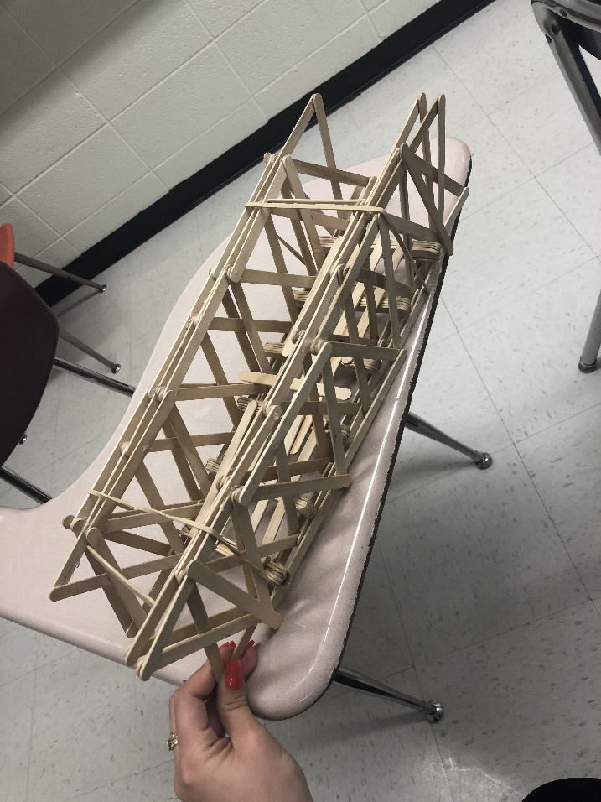

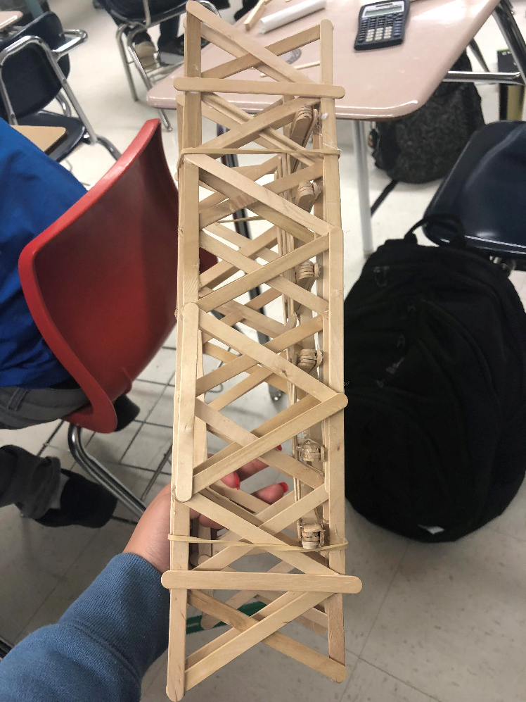

**Blueprint W/ Math Measurements:**

